5 DAYS ECOTOURISM AND SUSTAINABLE TOURISM CONFERENCE & NETWORKING EVENT (ESTC)
Tour Start Date: 27 July 2021, Tuesday
Tour Route: Tokat.

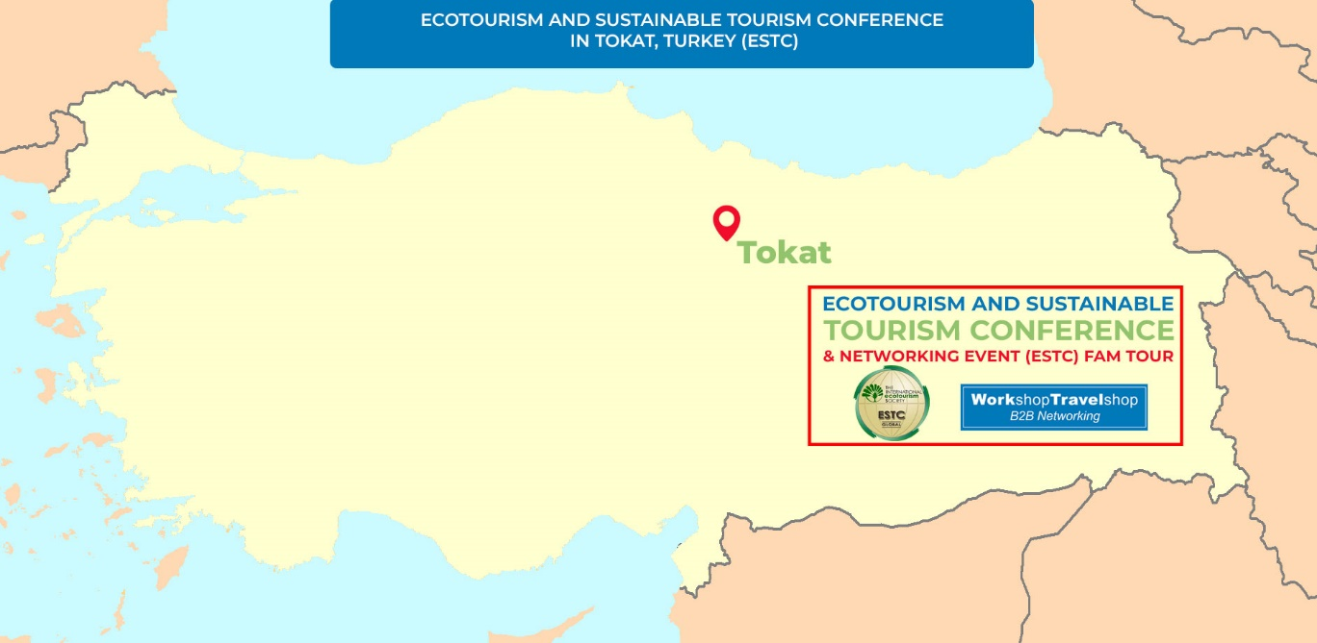

Summary
As The International Ecotourism Society, we organize an annual conference, the Ecotourism and Sustainable Tourism Conference (ESTC) and Business to Business Networking Event that is a widely considered the most important conference in ecotourism. The first ESTC took place in 2004, and this year we will hold the 16th ESTC in one of the best ecological destinations of Turkey,the beautiful town of Tokat. The conference will take place in July of 2021. Attendees will be able to see, feel, touch, cook and eat while having an educational sigthseeing tours in Turkey. Explore Turkey in all natural way and experience what its like to taste the produce, fresh off their branches, organically. Our program covers most of unique and natural destinations of beautiful Tokat, Turkey.
DAY 1: Tokat Arrival Day (27 July 2021, Tuesday)
(Dinner Included)
Arrival day via Sivas or Tokat Airport for our Ecotourism and Sustainable Tourism Conference and Networking Event. Check-in to the Hotel. City sight-seeing if you would like to have it on your own, walking through the promenade leisurely prior to the main attraction. Welcome Dinner and overnight at the Hotel.
DAY 2: Tokat Downtown Tour & Ecotourism Speaker Sessions (28 July 2021, Wednesday)
(Breakfast, Dinner , Lunch Included)
Today, after an early breakfast, we will have a short City Tour visiting the famous Tokat Castle, two major and awarded Museums (historical and ethnographical) in downtown area along with Wooden Historical Residences all around us. We will witness 900 years of history in 900 steps. After the City Tour, we will have a lunch and come back to the hotel. Registrations will take place by 13:00 and until 13:30. Opening Ceremony to start by 13:30. Break-out Ecotourism along with Keynote Speeches will start at 14:00 until 18:00. You will have coffee breaks in between the sessions. By 19.30, we will have Gala Dinner served. Overnight at the hotel.
DAY 3: Ecological Tour & Ecotourism and Sustainable Tourism Conference and Networking Event (29 July 2021, Thursday)
(Breakfast, Dinner , Lunch Included)
Today, after the breakfast, we will have trio sessions of B2B Meetings along with break-out sessions on certain topics by Ecotourism experts plus Keynote Authority Speaker sessions throughout the day from. Break-out Ecotourism along with Keynote Speeches to be performed between 10:00 and 18:00 B2B Networking Sessions between Buyers and Exhibitors to be performed between 13:00 and 18:00. During the B2B Networking sessions, All our Hosted Buyers to be present at their tables while exhibitors to visit them in person. By 19.30, we will have dinner served. Overnight at the hotel.
DAY 4: Lake Almus, A traditional Village Visit & Peach Picking, Village Dinner and Turkish Bath (30 July 2021, Friday)
(Breakfast, Dinner , Lunch Included )
After breakfast, we will see Lake Almus, one of the largest lakes of Turkey where we will witness the variety of fish on a walking tour and after an Al Fresco lunch by the water, we will visit a village to enjoy all natural & organic food along with villagers and take a part in Folk and traditional dances, depart for peach and seasonal veggie-fruit picking at its source. Attendees will enjoy nature up close that empathize the sense of being part of the soil. Eating the peaches fresh off the branch appreciating the greatness and witness the earth. Afterwards, we will be having authentic Cuisine samples for dinner and you are cooking! Today, we will see the honored and hospitable villagersâ€™ working conditions and cooking methods, witnessing their farm life. We will see the domestic animals all around us. An opportunity to have a perfect finish with a SPA experience at a classical Turkish Bath. Overnight at the hotel.
DAY 5: End of Ecotourism and Sustainable Tourism Conference and Networking Event (31 July 2021, Saturday)
(Breakfast Included )
We hope you have enjoyed our Ecotourism and Sustainable Tourism Conference and Networking Event in Tokat. We hope this was a memorable event for you and looking forward to see you again on another event of ours. Thank you for joining us.

INCLUDES
- Return Airport Transfer Services
- 4 Nights hotel accommodation in Tokat
- 4 Open Buffet Breakfasts
- 3 Lunches
- 3 Dinners
- 1 Gala Dinner
- Guided Tokat City Tour
- Guided Almus Lake Visit
- Guided Village & Farm Visits
- B2B Networking Event Participation
- Ecotourism Speaker Sessions
- English speaking tour guides

EXCLUDES
- International flights
- Insurance
- Country entry Visa
- Items of a personal nature such as alcoholic beverages, cold drinks, laundry etc.
- Any others expenses that are not mentioned in the included section

TERMS AND CONDITIONS
- Abide by the event calendar.
- Act in line with departure times.
- Hosted Buyers not to promote their own “incoming” services to the participants and if detected, would be disqualified and charged for the full fee.
- Minimum 30 pre-appointments taken per Hosted Buyers that to be signed by the appointee.
- Accommodations assigned should be taken into consideration and may not be altered during the trip in Turkey.
- Flight details to be registered on the system and we are not responsible of transfer services for the ones that are not registered.
- Please check your appointments and business cards.
- Only registered parties can enroll in Hosted Buyer Program. No one else can be invited without prior permission. Only the officially invited ones may stay through the event.
- We are expecting all Hosted Buyers to pay necessary attention and care for this event.
- You can ask for help of our team to be located in Hosted Buyer area throughout the event.
- Accepted invitations to Hosted Buyers are non-transferable. In case, where the Hosted Buyer is no longer able to attend, another attendee from their organization may replace with a renewed application, placed 45 days prior.
- Hosted Buyers who do not inform the Organizer of their cancellation and do not participate in the program, will be deemed a No-Show at 100%.
- All cancellations are subject to a written request and to be confirmed in return.
- Land tours “only” cancellation policy: Fully refundable in any cases and credit towards to the next event under Force Majeure conditions till 3 weeks event start date. 3 Weeks before 100% credit, 2 Weeks before Non-refundable.
P.S Whether you have altered the dates and/or any Event and Fam Trip purchases made by you from our product selection, you may use the credit by the rates as indicated above towards your purchases for the duration of 1 years on Workshop TravelShop events.

